# ReadMe

## About the Project/Project Title

The Animal Manager program is made to support Grazioso Salvare in management of their rescue animal training.

## Motivation

This program exists to make the process of finding suitable animals for various rescue organizations easier and faster for everyone.

## Installation

The program requires the AnimalShelter Module within the same file directory as the program to function. AnimalShelter holds the tools for accessing the database where animal data is stored.

## Usage

### 

### Here are the code for the filter buttons. Here they each filter options for 3 different types of rescue dog criteria.

### 

This chunk of code is the functionality of the buttons. You can see what each button filters down to. The fourth button just resets the filtering settings. The use of n_clicks_timstamp instead of n_clicks allows the triggering of each button after one click by tracking the time when the buttons were clicked.



The btns put into a list (timestamps) and then the highest timestamp is found and uses that button’s functionality.

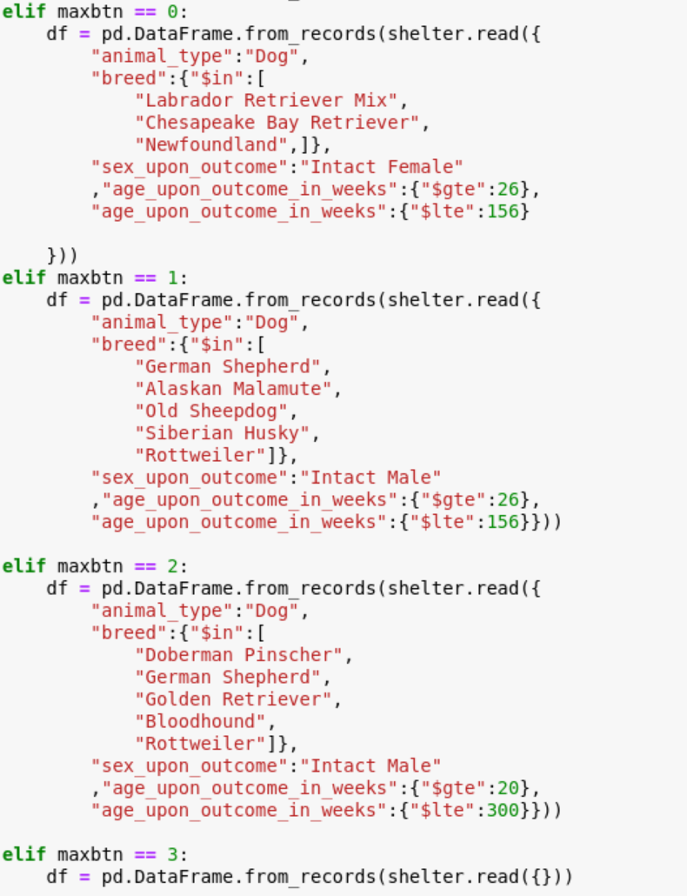

### Tests

You can test the button just by running the program and clicking them. This was the hardest test for me to pass when creating this program. You’ll see the data table change after pressing a button if the buttons are working. The pie graph and geolocator map will also update.

## Contact

Your name: Ryan Reese